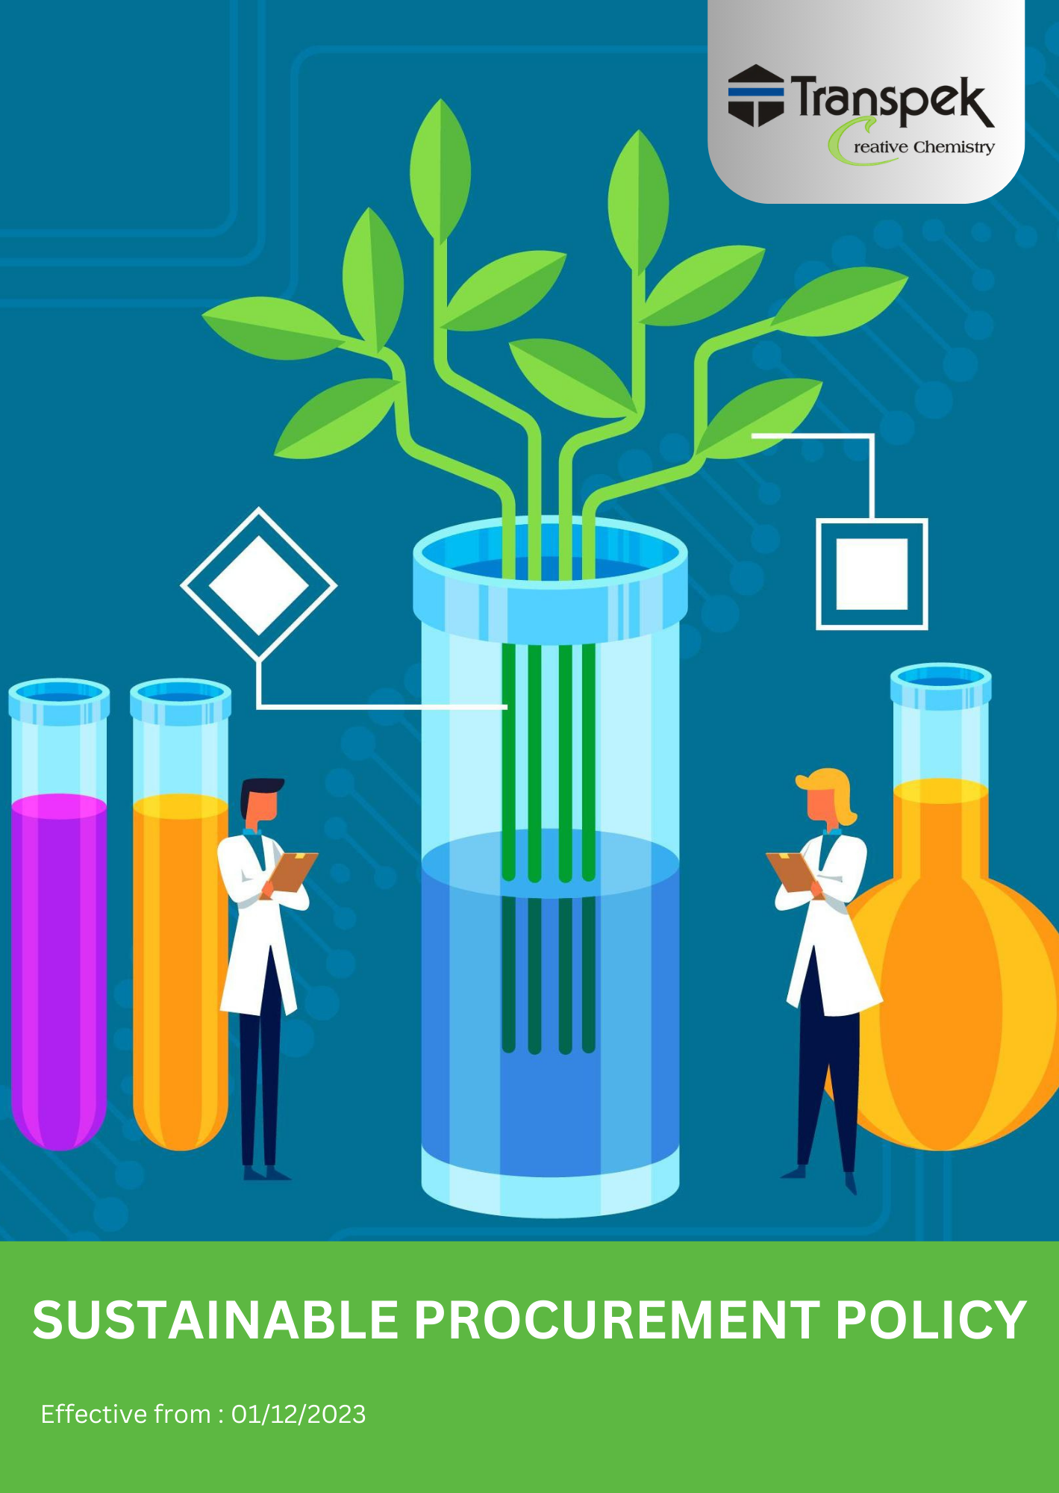

INDEX

INTRODUCTION 3
SCOPE 3
POLICY STATEMENT 3
KEY FOCUS AREA 4
QUALITATIVE TARGETS 4
QUANTITATIVE TARGETS 5
GENERAL TARGETS- 6
RESPONSIBILITY 6
REPORTING 8
COVERED SDGS 8
CONTINUOUS IMPROVEMENT 8
REVIEW MECHANISM 9
REVISION HISTORY 9
EMPLOYEE ACKNOWLEDGMENT FORM: SUSTAINABLE PROCUREMENT 10

INTRODUCTION
At Transpek Industry Limited, we are committed to integrating sustainability into every aspect of our procurement process. As a leader in the chemical manufacturing industry, we recognize that our purchasing decisions can have far-reaching environmental, social, and economic impacts. Our Sustainable Procurement Policy is designed to ensure that we source goods and services in a way that supports environmental protection, ethical labor practices, and long-term economic viability.
This policy aims to drive positive change across our supply chain, contributing to the well-being of both our stakeholders and the planet. Through collaboration with our suppliers, we aim to set industry standards for sustainable procurement practices and demonstrate our commitment to responsible business operations.

SCOPE
This policy applies to all procurement activities of Transpek Industry Limited, including materials, products, and services sourced from our suppliers, contractors, and other third parties. It covers all employees, subcontractors, and other stakeholders involved in our supply chain, regardless of location.
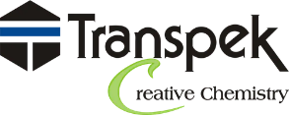 | Transpek Industry Limited
 | 4th Floor, Lilleria 1038 Gotri-Sevasi Road 390021 Vadodara, Gujarat India
 | At & Post: Ekalbara, Taluka: Padra, Dist.: Vadodara, 391440 Gujarat India
 | https://transpek.com/

POLICY STATEMENT
Sustainability is at the core of Transpek Industry Limited procurement practices. We are committed to:
- Sourcing materials and services in a manner that minimizes negative environmental impacts.
- Supporting suppliers who adhere to high standards of labour rights, fair wages, and safe working conditions.
- Encouraging transparency and traceability throughout the supply chain to promote ethical and sustainable sourcing.
- Ensuring that our procurement activities align with our broader goals of environmental protection, social responsibility, and ethical business practices.

KEY FOCUS AREA
Supplier Environmental Issues
- Promote environmental responsibility throughout the supply chain by encouraging suppliers to comply with applicable environmental laws, regulations, permits, and sustainability requirements.
- Encourage suppliers to maintain relevant environmental management systems, certifications, and environmental compliance documentation.
- Communicate environmental expectations and sustainable procurement requirements to suppliers and support continuous environmental improvement initiatives.
Supplier Social Issues
- Promote respect for labour rights, human rights, occupational health and safety, and ethical employment practices throughout the supply chain.
- Prohibit child labour, forced labour, bonded labour, human trafficking, discrimination, and other unethical labour practices within the supply chain.
- Encourage suppliers to maintain appropriate labour, health & safety, and human rights documentation and demonstrate compliance with applicable legal requirements.
Supplier Code of Conduct and ESG Compliance
- Require suppliers to acknowledge and comply with Transpek Industry Limited's Supplier Code of Conduct and sustainability expectations.
- Conduct ESG assessments, supplier evaluations, and risk-based reviews to monitor supplier performance.
- Work collaboratively with suppliers to address identified gaps and improve ESG performance.
Training, Capacity Building and Supplier Engagement
- Enhance awareness of Environmental, Social, and Governance (ESG) principles among suppliers and procurement personnel.
- Conduct supplier engagement initiatives, training programs, and awareness activities on sustainability-related topics.
- Encourage suppliers to participate in ESG self-assessments and continuous improvement initiatives.

QUALITATIVE TARGETS
Supplier Environmental Issues
- Promote supplier compliance with applicable environmental regulations, permits, and sustainability requirements.
- Encourage suppliers to maintain environmental management systems and relevant environmental certifications where applicable.
- Strengthen communication of environmental expectations and sustainable procurement practices throughout the supply chain.
Supplier Social Issues
- Promote awareness of labour rights, human rights, occupational health and safety, and ethical employment practices among suppliers.
- Encourage suppliers to prevent child labour, forced labour, bonded labour, discrimination, and human trafficking within their operations.
- Support suppliers in maintaining labour, health & safety, and human rights compliance documentation.
Supplier Code of Conduct and ESG Compliance
- Communicate and promote Transpek's Supplier Code of Conduct to suppliers and business partners.
- Conduct ESG assessments, supplier reviews, and sustainability audits to evaluate supplier performance.
- Encourage suppliers to address identified gaps through corrective action and continuous improvement initiatives.
Training, Capacity Building and Supplier Engagement
- Provide sustainability-related awareness and training programs for suppliers and procurement personnel.
- Encourage suppliers to participate in ESG self-assessments and supplier engagement programs.
- Strengthen supplier understanding of environmental, social, governance, ethical business conduct, and responsible sourcing expectations

QUANTITATIVE TARGETS
Supplier Environmental Issues
- Supplier Environmental Compliance:
- Maintain 100% compliance with applicable environmental requirements among approved suppliers by FY 2029-30.

- Supplier Environmental Documentation:
- Increase collection of environmental compliance documents (e.g., environmental permits, ISO 14001 certificates, or equivalent documents) from key suppliers by 25% by FY 2029-30 compared to FY 2022-23.

- Supplier Sustainability Communication:
- Communicate environmental expectations and sustainability requirements to 100% of new suppliers by FY 2029-30.

Supplier Social Issues
- Human Rights and Labour Awareness:
- Increase supplier participation in human rights, labour rights, and ethical business awareness programs by 20% by FY 2029-30 from the baseline year FY 2022-23.

- Supplier Code of Conduct Acknowledgement:
- Obtain acknowledgement of the Supplier Code of Conduct from at least 90% of key suppliers by FY 2029-30.

- Child Labour, Forced Labour, and Human Trafficking Compliance:
- Maintain 100% compliance with supplier requirements relating to child labour, forced labour, bonded labour, and human trafficking by FY 2029-30.

- Supplier Social Documentation:
- Increase collection of supplier labour, health & safety, and human rights compliance documentation by 25% by FY 2029-30 compared to FY 2022-23.

- Labour and Human Rights Compliance
- Maintain 100% compliance among approved suppliers with applicable labour laws, human rights requirements, and employment regulations established by local, national, and other relevant regulatory authorities by FY 2029-30, using FY 2022-23 as the baseline year

GENERAL TARGETS-
- Supplier Training on environmental, social and governance topics
- Conduct a minimum of one or two training sessions per year for suppliers on environmental, social and governance topics.

- Procurement Staff Training and Monitoring
- Ensure 100% of procurement staff undergo annual training on environmental sustainability, social responsibility & governance Compliance by FY 2029-30.

- Supplier ESG On-Site Audits
- Conduct ESG audits for at least 20% of key suppliers by FY 2029-30.

- Encouraging Supplier ESG Self-Assessments
- Ensure 30% of key suppliers complete ESG self-assessment questionnaires annually by FY 2025-26.

- Supplier Code of Conduct Acknowledgement
- Ensure 100% of key suppliers acknowledge, sign, and comply with Transpek Industry Limited's Supplier Code of Conduct by FY 2029-30, from the baseline year FY 2022-23.

RESPONSIBILITY
Chief Procurement Officer (CPO)
- Leadership in Policy Enforcement: Provide overall guidance and ensure that the Sustainable Procurement Policy aligns with Transpek’s strategic goals.
- Approval of Suppliers: Authorize collaborations with suppliers based on compliance with sustainability standards.
- Annual Review Oversight: Supervise the annual policy review and updates, ensuring continued alignment with regulatory and industry changes.
Sustainability and Procurement Team
- Policy Implementation: Execute day-to-day operations related to sustainable procurement practices and ensure compliance with policy standards.
- Supplier Assessments: Conduct regular assessments and audits of suppliers to confirm compliance with environmental, social, and governance (ESG) criteria.
- KPI Tracking and Reporting: Develop and monitor key performance indicators (KPIs) for sustainability in procurement, preparing reports for review by leadership.
Procurement Managers
- Supplier Selection and Evaluation: Ensure all suppliers meet the company's standards for environmental compliance, ethical sourcing, and fair labour practices.
- Waste and Emission Reduction Initiatives: Actively work with suppliers to implement waste reduction, eco-friendly packaging, and energy efficiency initiatives.
- Documentation and Transparency: Maintain thorough records of all supplier engagements, including sustainability certifications, reports, and compliance documents.
HR and Training Team
- Employee Training Programs: Facilitate training programs on sustainable procurement, ethical sourcing, and compliance with human rights standards.
- Policy Awareness Campaigns: Create awareness initiatives around the Sustainable Procurement Policy to ensure all employees understand and support its objectives.
- Feedback Collection: Gather feedback from employees on policy execution and suggest improvements based on on-ground insights.
Compliance Officers
- Regulatory Compliance Assurance: Ensure that all procurement activities comply with relevant environmental, labour, and human rights laws.
- Due Diligence in Human Rights: Conduct human rights due diligence across the supply chain, identifying and mitigating risks related to labour practices.
- Policy Violation Investigation: Investigate any potential breaches of the Sustainable Procurement Policy and ensure corrective actions are taken.
Environmental and Social Auditors
- Supplier Audit Execution: Conduct regular supplier audits to verify compliance with environmental and social standards, including waste management and fair labour practices.
- Report Preparation: Generate reports on supplier compliance status and provide recommendations for any needed improvements.
- Continuous Monitoring of Sustainability Standards: Stay updated on industry standards and regulations, ensuring Transpek’s policy remains at the forefront of sustainability practices.
Procurement Staff
- Policy Adherence: Follow the Sustainable Procurement Policy guidelines when making purchasing decisions.
- Responsible Sourcing Practices: Prioritize eco-friendly and ethical sourcing options in procurement operations.
- Awareness of Sustainability Goals: Actively participate in sustainability training sessions and support company initiatives to achieve sustainability targets

REPORTING
To ensure accountability and transparency in our sustainable procurement practices, Transpek Industry Limited will:
- Conduct regular assessments to monitor supplier compliance with our sustainability standards.

- Develop key performance indicators (KPIs) to measure the environmental and social performance of suppliers.

- Implement a traceability system to track the origin and movement of materials throughout the supply chain, ensuring that they comply with our ethical sourcing requirements.

- Publish an annual sustainability report detailing our procurement activities, progress toward sustainability targets, and any updates to our policy.

COVERED SDGS
 |  |  |  | 

CONTINUOUS IMPROVEMENT
Transpek Industry Limited is committed to continuously improving its procurement practices to meet evolving industry standards and stakeholder expectations. We regularly review and update this policy to align with best practices in the chemical manufacturing sector, focusing on environmental responsibility and social accountability. Collaboration with suppliers and industry partners helps us identify innovative solutions to reduce our environmental impact and promote ethical practices. We also benchmark our activities against the latest sustainability trends and establish feedback mechanisms to gather input from employees and stakeholders. This approach ensures that our procurement practices remain adaptive and responsive to emerging challenges in sustainability.

REVIEW MECHANISM
This policy will be reviewed annually by the Procurement and Sustainability Team to ensure that it remains relevant and effective. The review will consider feedback from stakeholders, supplier performance data, and changes in regulations or industry standards. Any updates to the policy will be communicated to all relevant parties, ensuring alignment with Transpek Industry Limited overall sustainability goals.

REVISION HISTORY
Revision No. | Revision Date | Description of Change
00 | 01-01-2023 | Initial release of the Labour & Human Rights Policy
01 | 01-04-2024 | Added the sections “Quantitative Targets” and “Qualitative Targets” and incorporated relevant SDGs
02 | 01-04-2025 | Revised sustainability targets with updated achievement timelines and added a formal Revision History table
03 | 01-04-2026 | Conducted the annual review of the Sustainable Procurement Policy – No changes required

(Signature)
Approved By:
Designations:
Last Review Date: 01-04-2026 Next Review Date: 01-04-2027

EMPLOYEE ACKNOWLEDGMENT FORM: SUSTAINABLE PROCUREMENT
I, acknowledge that I have received and read the Sustainable Procurement Policy of Transpek Industry Limited. I understand the company’s commitment to ethical sourcing, environmental stewardship, and social responsibility in all procurement activities.
I am aware of my responsibility to comply with this policy, including supporting sustainable practices, participating in relevant training, and adhering to the principles outlined within the policy. I recognize the importance of the company’s efforts to minimize environmental impacts and promote fair labour practices throughout our supply chain.
I understand that Transpek Industry Limited is dedicated to ensuring that all procurement decisions align with sustainability standards, and that any breach of this policy will not be tolerated. By signing this acknowledgment, I affirm my commitment to supporting the company’s objectives of sustainable procurement and fostering a responsible and inclusive workplace.

Employee Name: ______________________
Date: _______________
Employee Signature: ____________________

